Creador: David Rubio G.
Blog: https://soceame.wordpress.com/
GitHub: https://github.com/DRubioG
Fecha última modificación: 23/02/2025

Este es el pinout del Polarfire SoC Discovery Kit.
También tienes un documento y el pinout (PDC) en mi GitHub: https://github.com/DRubioG/PolarFire_SoC_FPGA_Discovery_Kit_Pinout

FPGA Pinout
Pin Name | Pin Number | Direction | Voltage | FPGA bank
CLK_50MHz | R18 | In | 1.8V | 0
LED1(LOW LEVEL ACTIVE) | T18 | Out | 1.8V | 0
LED2(LOW LEVEL ACTIVE) | V17 | Out | 1.8V | 0
LED3(LOW LEVEL ACTIVE) | U20 | Out | 1.8V | 0
LED4(LOW LEVEL ACTIVE) | U21 | Out | 1.8V | 0
LED5(LOW LEVEL ACTIVE) | AA18 | Out | 1.8V | 0
LED6(LOW LEVEL ACTIVE) | V16 | Out | 1.8V | 0
LED7(LOW LEVEL ACTIVE)** | U15 | Out | 1.8V | 0
SWITCH1 (LOW LEVEL ACTIVE) | T19 | In | 1.8V | 0
SWITCH2 (LOW LEVEL ACTIVE) | U18 | In | 1.8V | 0
DIP1 (LOW LEVEL ACTIVE) | U17 | In | 1.8V | 0
DIP2 (LOW LEVEL ACTIVE) | Y16 | In | 1.8V | 0
DIP3 (LOW LEVEL ACTIVE) | R17 | In | 1.8V | 0
DIP4 (LOW LEVEL ACTIVE) | AA15 | In | 1.8V | 0
DIP5 (LOW LEVEL ACTIVE) | AA20 | In | 1.8V | 0
DIP6 (LOW LEVEL ACTIVE) | Y20 | In | 1.8V | 0
DIP7 (LOW LEVEL ACTIVE) | V21 | In | 1.8V | 0
DIP8 (LOW LEVEL ACTIVE) | AA19 | In | 1.8V | 0
IO1 | V18 |  | 1.8V | 0
IO2 | W20 |  | 1.8V | 0
IO3 | Y19 |  | 1.8V | 0
IO4 | T17 |  | 1.8V | 0
IO5 | W16 |  | 1.8V | 0
IO6 | AA17 |  | 1.8V | 0
IO7 | V15 |  | 1.8V | 0
IO8 | Y15 |  | 1.8V | 0
UART_TX | W21 | Out | 1.8V | 0
UART_RX | Y21 | In | 1.8V | 0
RPI_GPIO3 | E18 |  | 2.5V/3.3V (J45)* | 1
RPI_GPIO5 | F18 |  | 2.5V/3.3V (J45)* | 1
RPI_GPIO7 | E12 |  | 2.5V/3.3V (J45)* | 1
RPI_GPIO8 | A20 |  | 2.5V/3.3V (J45)* | 1
RPI_GPIO10 | B21 |  | 2.5V/3.3V (J45)* | 1
RPI_GPIO11 | G18 |  | 2.5V/3.3V (J45)* | 1
RPI_GPIO12 | E10 |  | 2.5V/3.3V (J45)* | 1
RPI_GPIO13 | F21 |  | 2.5V/3.3V (J45)* | 1
RPI_GPIO15 | F20 |  | 2.5V/3.3V (J45)* | 1
RPI_GPIO16 | E21 |  | 2.5V/3.3V (J45)* | 1
RPI_GPIO18 | F19 |  | 2.5V/3.3V (J45)* | 1
RPI_GPIO22 | A19 |  | 2.5V/3.3V (J45)* | 1
RPI_GPIO29 | D17 |  | 2.5V/3.3V (J45)* | 1
RPI_GPIO31 | D18 |  | 2.5V/3.3V (J45)* | 1
RPI_GPIO32 | B20 |  | 2.5V/3.3V (J45)* | 1
RPI_GPIO33 | A15 |  | 2.5V/3.3V (J45)* | 1
RPI_GPIO35 | B19 |  | 2.5V/3.3V (J45)* | 1
RPI_GPIO36 | B15 |  | 2.5V/3.3V (J45)* | 1
RPI_GPIO37 | B17 |  | 2.5V/3.3V (J45)* | 1
RPI_GPIO38 | B14 |  | 2.5V/3.3V (J45)* | 1
RPI_GPIO40 | E13 |  | 2.5V/3.3V (J45)* | 1
MIKROBUS_AN | G12 |  | 2.5V/3.3V (J45)* | 1
MIKROBUS_RST(PULL-UP) | B16 |  | 2.5V/3.3V (J45)* | 1
MIKROBUS_CS(PULL-UP) | C16 |  | 2.5V/3.3V (J45)* | 1
MIKROBUS_SCK | E17 |  | 2.5V/3.3V (J45)* | 1
MIKROBUS_MISO | A18 |  | 2.5V/3.3V (J45)* | 1
MIKROBUS_MOSI | E11 |  | 2.5V/3.3V (J45)* | 1
MIKROBUS_PWM | D13 |  | 2.5V/3.3V (J45)* | 1
MIKROBUS_INT(PULL-UP) | G17 |  | 2.5V/3.3V (J45)* | 1
MIKROBUS_RX | E14 |  | 2.5V/3.3V (J45)* | 1
MIKROBUS_TX | E15 |  | 2.5V/3.3V (J45)* | 1
MIKROBUS_SCL(PULL-UP) | D11 |  | 2.5V/3.3V (J45)* | 1
MIKROBUS_SDA(PULL-UP) | D12 |  | 2.5V/3.3V (J45)* | 1
ETH_MDC(PULL-UP) | D15 | Out | 2.5V/3.3V (J45)* | 1
ETH_MDIO(PULL-UP) | D16 | Out | 2.5V/3.3V (J45)* | 1
ETH_MDINTB(PULL-UP) | A13 | Out | 2.5V/3.3V (J45)* | 1
ETH_RESETn(PULL-UP) | A14 | Out | 2.5V/3.3V (J45)* | 1
ETH_RXLOS | A17 | Out | 2.5V/3.3V (J45)* | 1
ETH_TXDISn(PULL-UP) | E20 | Out | 2.5V/3.3V (J45)* | 1
GPIO_MIPI_RX_N0 | B11 | Out | 2.5V/3.3V (J45)* | 1
GPIO_MIPI_RX_P0 | C11 | Out | 2.5V/3.3V (J45)* | 1
GPIO_MIPI_RX_N1 | A10 | Out | 2.5V/3.3V (J45)* | 1
GPIO_MIPI_RX_P1 | B10 | Out | 2.5V/3.3V (J45)* | 1
GPIO_MIPI_RX_CKN | B12 | Out | 2.5V/3.3V (J45)* | 1
GPIO_MIPI_RX_CKP | A12 | Out | 2.5V/3.3V (J45)* | 1
CAM_EN | Y14 | In | 1.8V | 0
CAM_I2C_SDA(PULL-UP) | T20 | In | 1.8V | 0
CAM_I2C_SCL(PULL-UP) | T21 | In | 1.8V | 0
CAM_GPIO | Y17 | In | 1.8V | 0
*
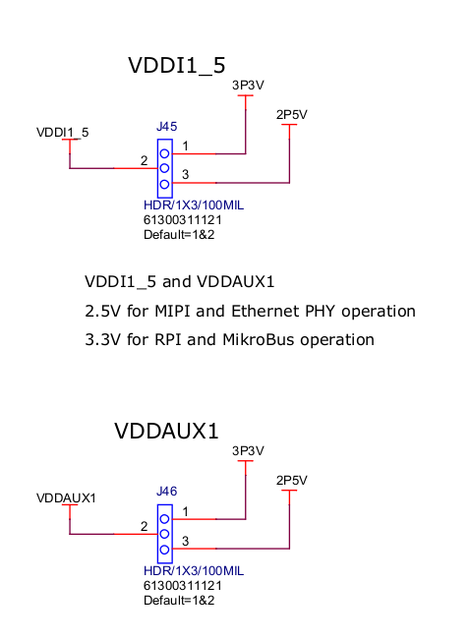
** LED8 controlled by MSS with 3.3V

Live Probes (J12). Debugging pins:
Pin | Name | Function
1 | LPRB_B (C20) | Live Probe B
2 | LPRB_A (C21) | Live Probe A
3 | GND
4 | GND

Raspberry Pi 4 Interface
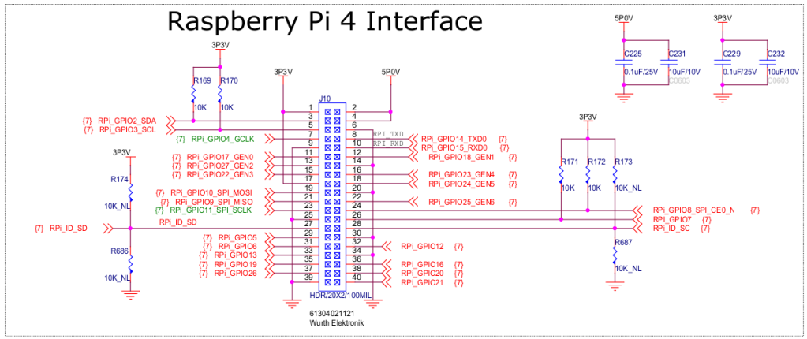
PIN CONNECTOR | PIN FPGA | TYPE PIN | VOLTAGE | BANK
1 |  | SOURCE | 3.3V
2 |  | SOURCE | 5V
3 | E18 | HSIO | 2.5V/3.3V (J45) | 1
4 |  | SOURCE | 5V
5 | F18 | HSIO | 2.5V/3.3V (J45) | 1
6 |  | SOURCE | GND
7 | E12 | HSIO | 2.5V/3.3V (J45) | 1
8 | A20 | HSIO | 2.5V/3.3V (J45) | 1
9 |  | SOURCE | GND
10 | B21 | HSIO | 2.5V/3.3V (J45) | 1
11 | G18 | HSIO | 2.5V/3.3V (J45) | 1
12 | E10 | HSIO | 2.5V/3.3V (J45) | 1
13 | F21 | HSIO | 2.5V/3.3V (J45) | 1
14 |  | SOURCE | GND
15 | F20 | HSIO | 2.5V/3.3V (J45) | 1
16 | E21 | HSIO | 2.5V/3.3V (J45) | 1
17 |  | SOURCE | 3.3V
18 | F19 | HSIO | 2.5V/3.3V (J45) | 1
19 | A4 | MSS | 3.3V | 2
20 |  | SOURCE | GND
21 | B4 | MSS | 3.3V | 2
22 | A19 | HSIO | 2.5V/3.3V (J45) | 1
23 | D6 | MSS | 3.3V | 2
24 | D5 | MSS | 3.3V | 2
25 |  | SOURCE | GND
26 | B2 | MSS | 3.3V | 2
27 | D1 | MSS | 3.3V | 2
28 | C2 | MSS | 3.3V | 2
29 | D17 | HSIO | 2.5V/3.3V (J45) | 1
30 |  | SOURCE | GND
31 | D18 | HSIO | 2.5V/3.3V (J45) | 1
32 | B20 | HSIO | 2.5V/3.3V (J45) | 1
33 | A15 | HSIO | 2.5V/3.3V (J45) | 1
34 |  | SOURCE | GND
35 | B19 | HSIO | 2.5V/3.3V (J45) | 1
36 | B15 | HSIO | 2.5V/3.3V (J45) | 1
37 | B17 | HSIO | 2.5V/3.3V (J45) | 1
38 | B14 | HSIO | 2.5V/3.3V (J45) | 1
39 |  | SOURCE | GND
40 | E13 | HSIO | 2.5V/3.3V (J45) | 1

MIKROBUS
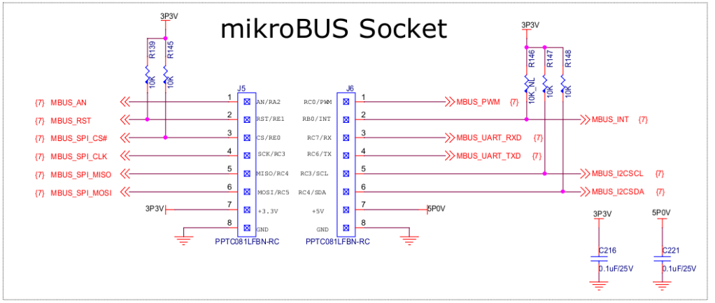
CONNECTOR | PIN | NAME | FPGA PIN | VOLTAGE | BANK
J5 | 1 | MIKROBUS_AN | G12 | 2.5V/3.3V (J45) | 1
J5 | 2 | MIKROBUS_RST(PULL-UP: 3V3) | B16 | 2.5V/3.3V (J45) | 1
J5 | 3 | MIKROBUS_CS(PULL-UP: 3V3) | C16 | 2.5V/3.3V (J45) | 1
J5 | 4 | MIKROBUS_SCK | E17 | 2.5V/3.3V (J45) | 1
J5 | 5 | MIKROBUS_MISO | A18 | 2.5V/3.3V (J45) | 1
J5 | 6 | MIKROBUS_MOSI | E11 | 2.5V/3.3V (J45) | 1
J5 | 7 | 3V3
J5 | 8 | GND
J6 | 1 | MIKROBUS_PWM | D13 | 2.5V/3.3V (J45) | 1
J6 | 2 | MIKROBUS_INT(PULL-UP: 3V3) | G17 | 2.5V/3.3V (J45) | 1
J6 | 3 | MIKROBUS_RX | E14 | 2.5V/3.3V (J45) | 1
J6 | 4 | MIKROBUS_TX | E15 | 2.5V/3.3V (J45) | 1
J6 | 5 | MIKROBUS_SCL(PULL-UP: 3V3) | D11 | 2.5V/3.3V (J45) | 1
J6 | 6 | MIKROBUS_SDA(PULL-UP: 3V3) | D12 | 2.5V/3.3V (J45) | 1
J6 | 7 | 5V
J6 | 8 | GND

ETHERNET (GPIO & MSS Pins)

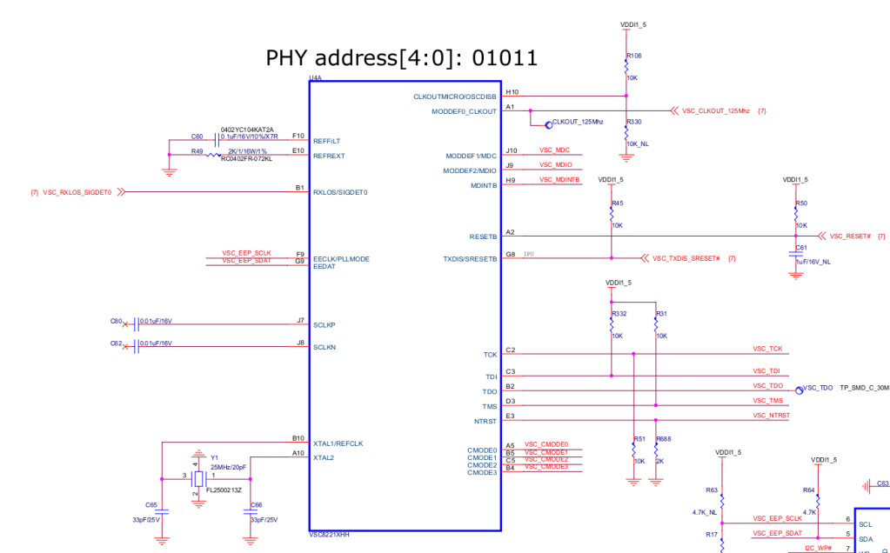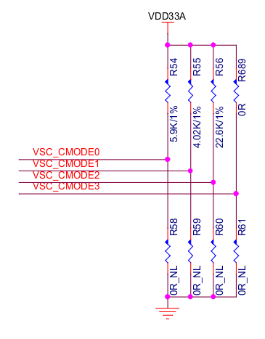
*R58, R59, R60, R61 : NM → CMODE: 2
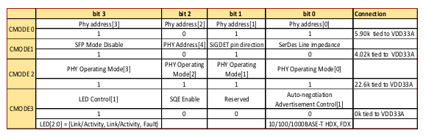
Name | FPGA Pin | Type | Voltage | Bank
ETH_MDC(PULL-UP) | D15 | Out | 2.5V/3.3V (J45) | 1
ETH_MDIO(PULL-UP) | J9 | Out | 2.5V/3.3V (J45) | 1
ETH_MDINTB(PULL-UP) | A13 | Out | 2.5V/3.3V (J45) | 1
ETH_RESETn(PULL-UP) | A14 | Out | 2.5V/3.3V (J45) | 1
ETH_RXLOS | A17 | Out | 2.5V/3.3V (J45) | 1
ETH_TXDISn(PULL-UP) | E20 | Out | 2.5V/3.3V (J45) | 1
… Other pins are MSS pins
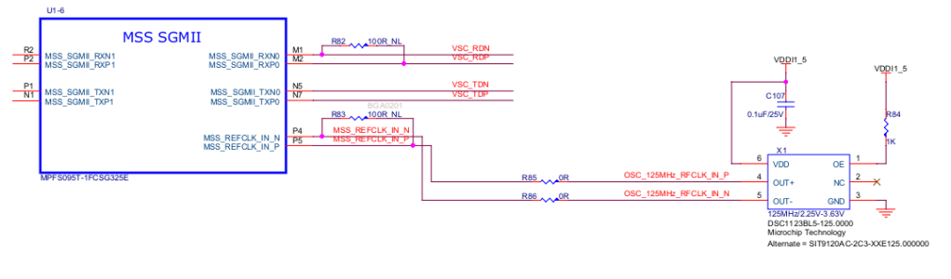

MIPI Conector
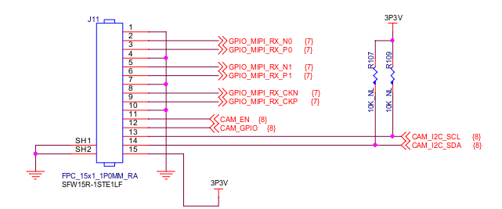
Pin | Name | FPGA Pin | Type | Voltage | Bank
1 | GND
2 | GPIO_MIPI_RX_N0 | B11 | Out | 2.5V/3.3V (J45) | 1
3 | GPIO_MIPI_RX_P0 | C11 | Out | 2.5V/3.3V (J45) | 1
4 | GND
5 | GPIO_MIPI_RX_N1 | A10 | Out | 2.5V/3.3V (J45) | 1
6 | GPIO_MIPI_RX_P1 | B10 | Out | 2.5V/3.3V (J45) | 1
7 | GND
8 | GPIO_MIPI_RX_CKN | B12 | Out | 2.5V/3.3V (J45) | 1
9 | GPIO_MIPI_RX_CKP | A12 | Out | 2.5V/3.3V (J45) | 1
10 | GND
11 | CAM_EN | Y14 | In | 1.8V | 0
12 | CAM_GPIO | Y17 | In | 1.8V | 0
13 | CAM_I2C_SDA(PULL-UP) | T20 | In | 1.8V | 0
14 | CAM_I2C_SCL(PULL-UP) | T21 | In | 1.8V | 0
15 | GND

7 Segment Display
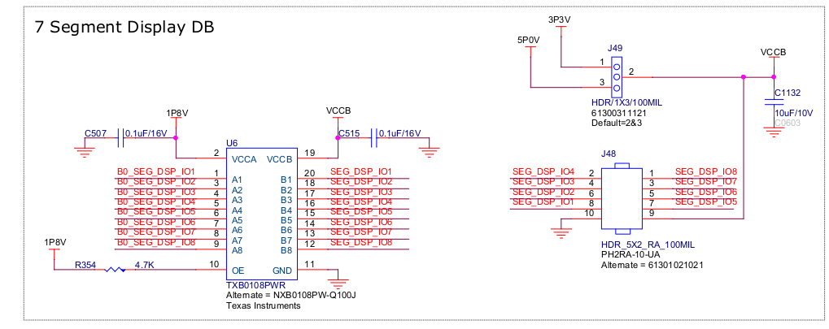
FPGA Output voltage: 1.8V → Pin voltage: 3V3 / 5V (J49)
Name | FPGA PIN | Type | Voltage | FPGA Bank
IO1 | V18 | Out | 1.8V | 0
IO2 | W20 | Out | 1.8V | 0
IO3 | Y19 | Out | 1.8V | 0
IO4 | T17 | Out | 1.8V | 0
IO5 | W16 | Out | 1.8V | 0
IO6 | AA17 | Out | 1.8V | 0
IO7 | V15 | Out | 1.8V | 0
IO8 | Y15 | Out | 1.8V | 0

SD CARD (MSS Pins)

